Day 4 – JIRA Issue Types & Issue Creation
Date: 30-Dec-2025
Learning Objective
To understand different JIRA issue types—Epic, Story, Task, and Bug—along with their meanings and purposes, and to gain hands-on experience by creating issues of each type for effective work breakdown and tracking.
Detailed Learning Description
1. JIRA Issue Types Overview
On Day 4, I learned about issue types in JIRA, which define the nature of work being tracked within a project. Issue types help teams classify work, organize tasks, plan sprints, and monitor progress throughout the project lifecycle.
2. Epic
Definition:
• An Epic is a large body of work that represents a major feature, objective, or initiative which cannot be completed in a single sprint.
Learning Details:
• Epics group related stories, tasks, and bugs under a common goal
• They support long-term planning and high-level progress tracking
• Epics help teams visualize big-picture objectives
My practice:
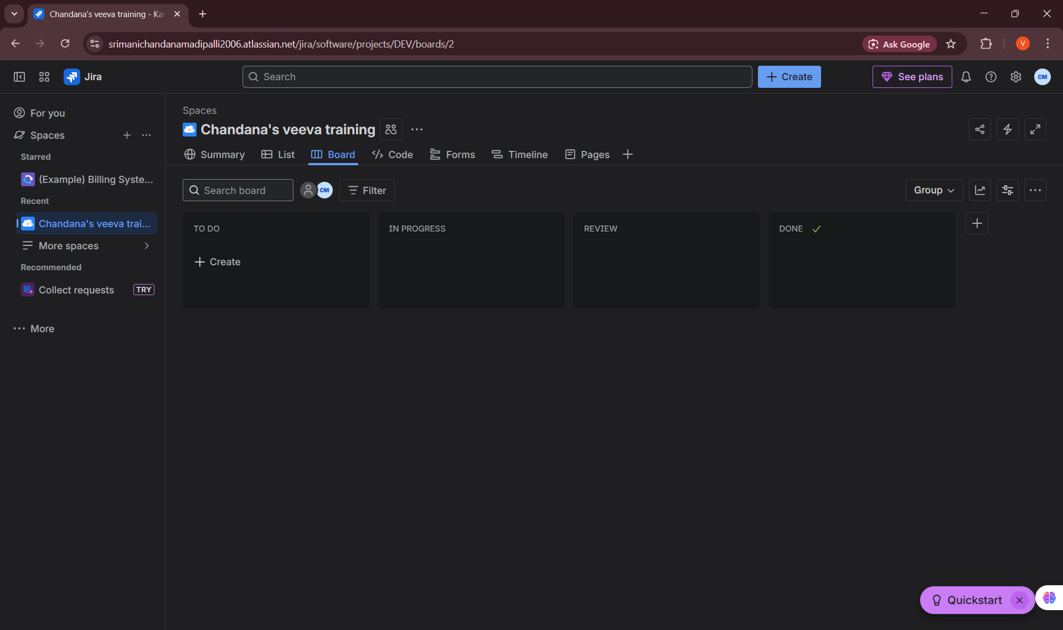

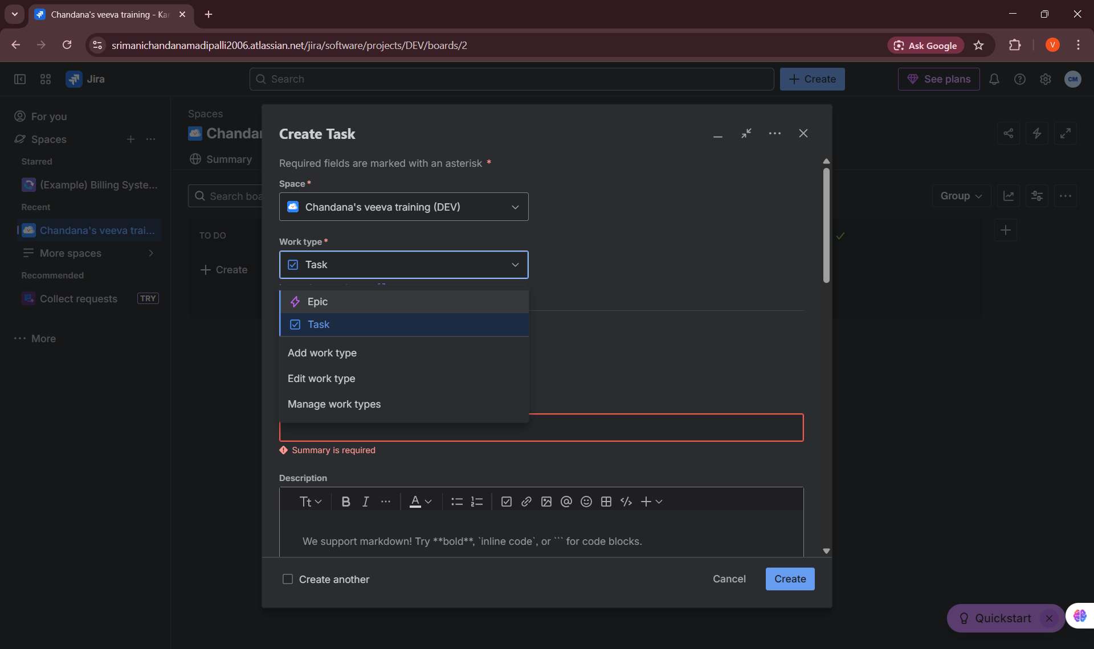

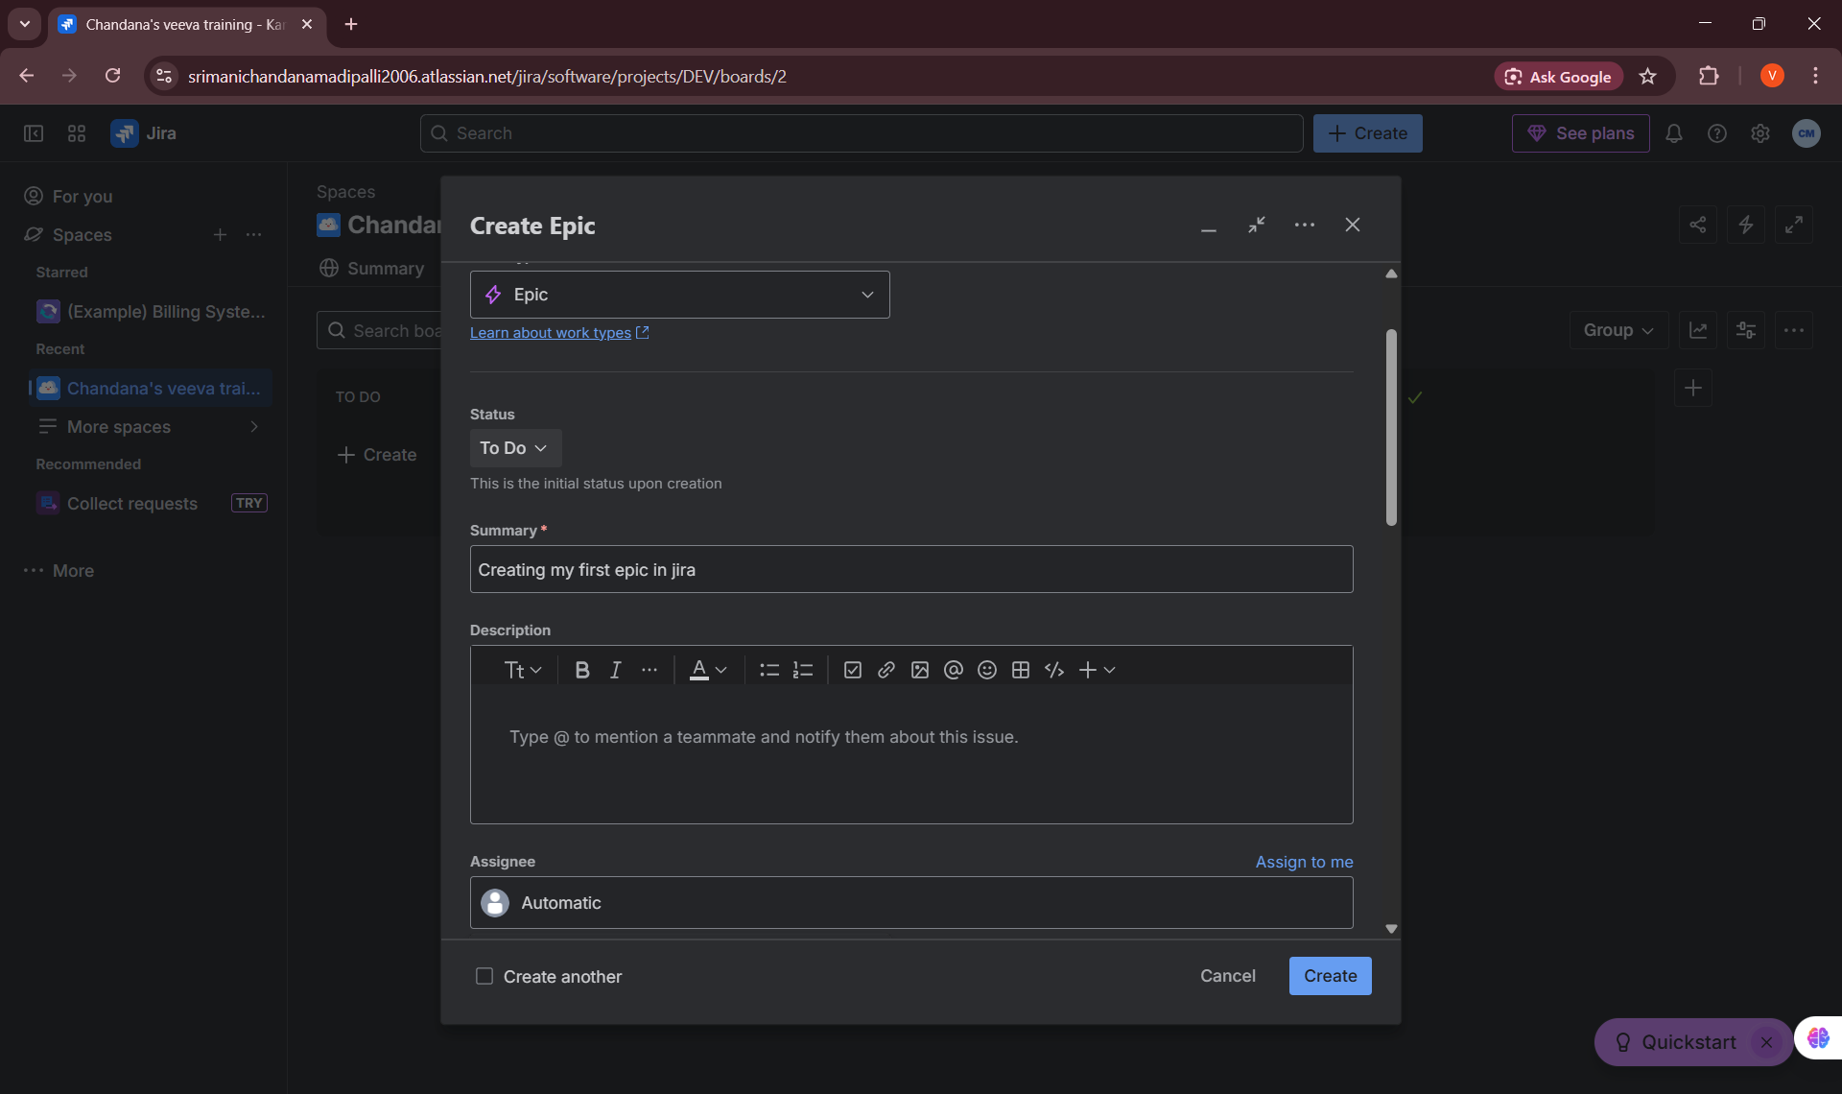

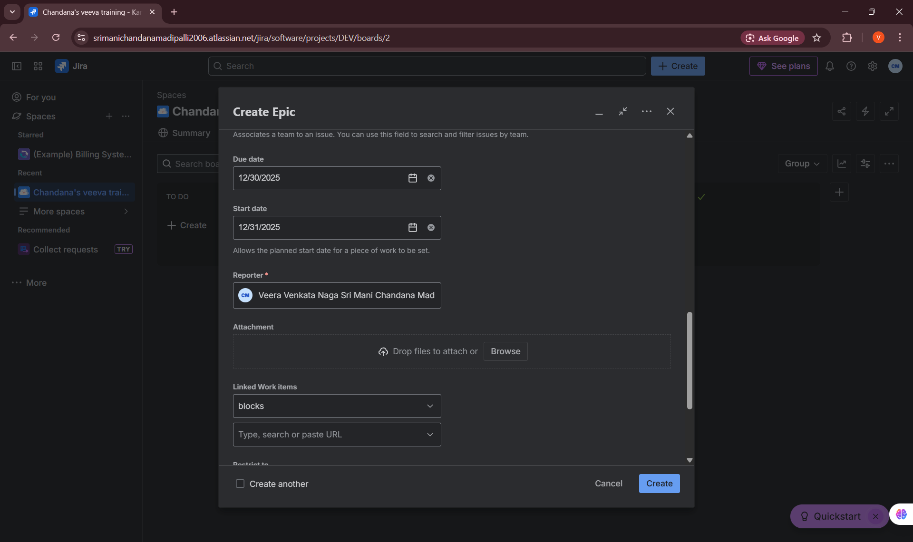

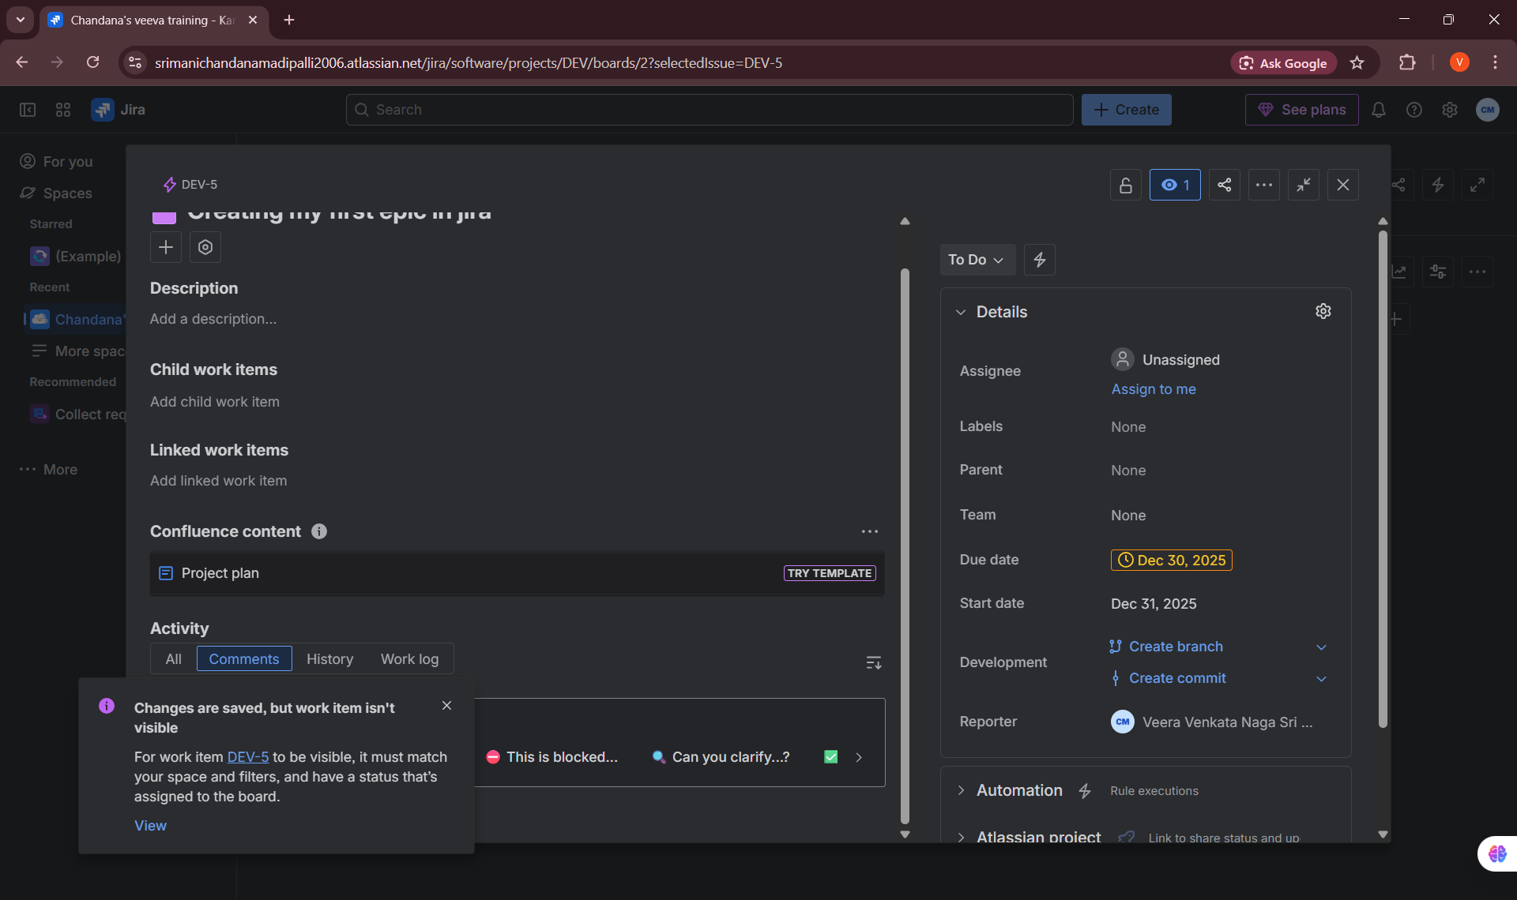
3. Story
Definition:
• A Story (User Story) is a requirement written from the end-user’s perspective, describing a specific functionality or feature that delivers value to the user.
Learning Details:
• Stories are usually small enough to be completed within one sprint
• Stories are often linked to an epic for better requirement traceability
• Stories drive sprint planning and development activities
My practice:
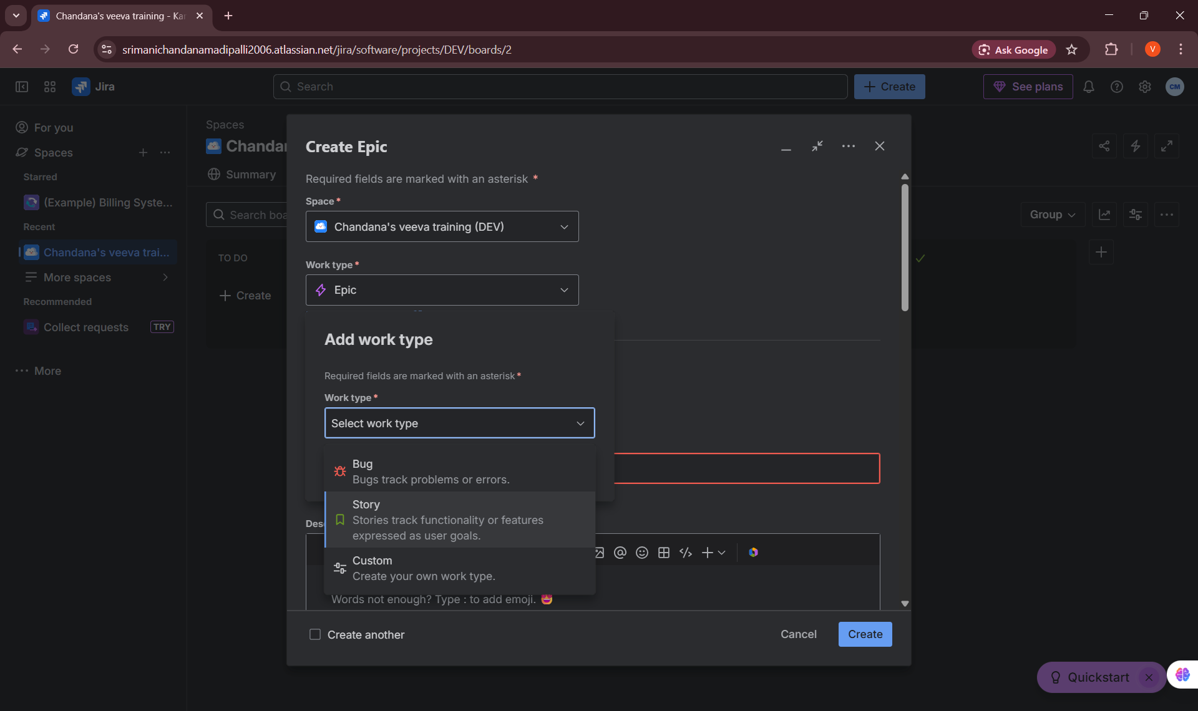

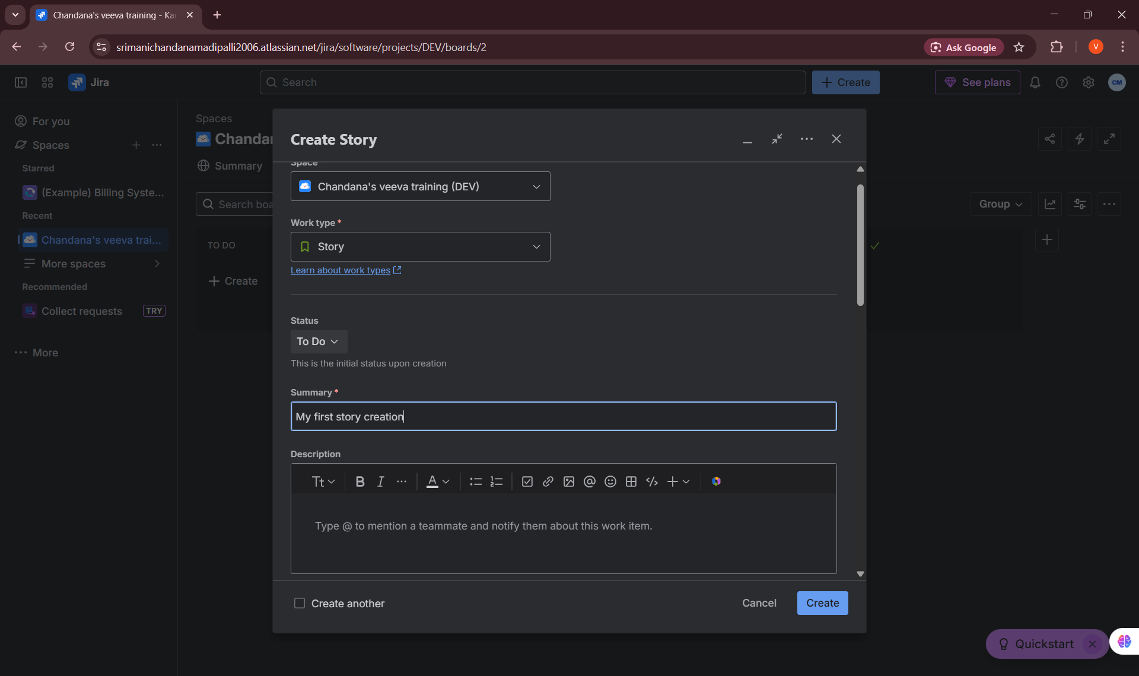

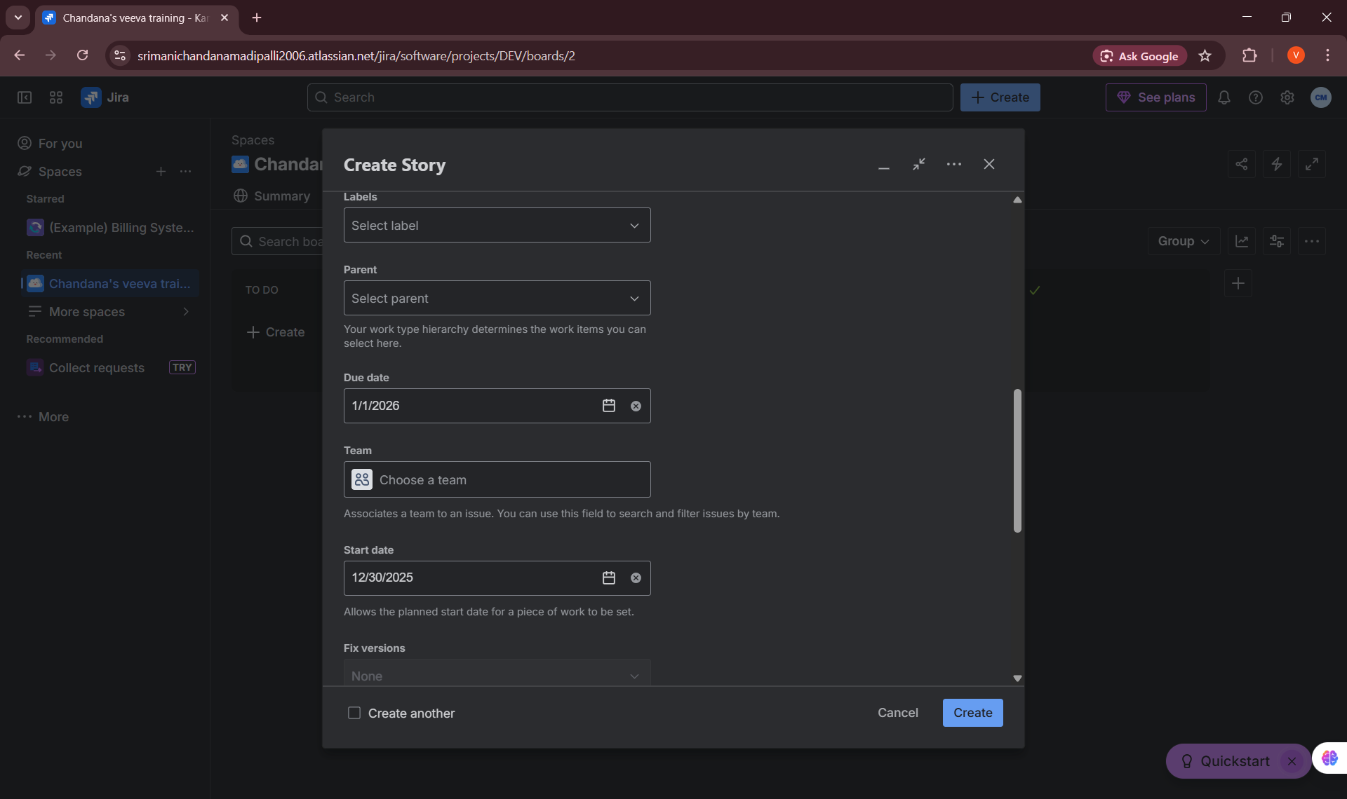

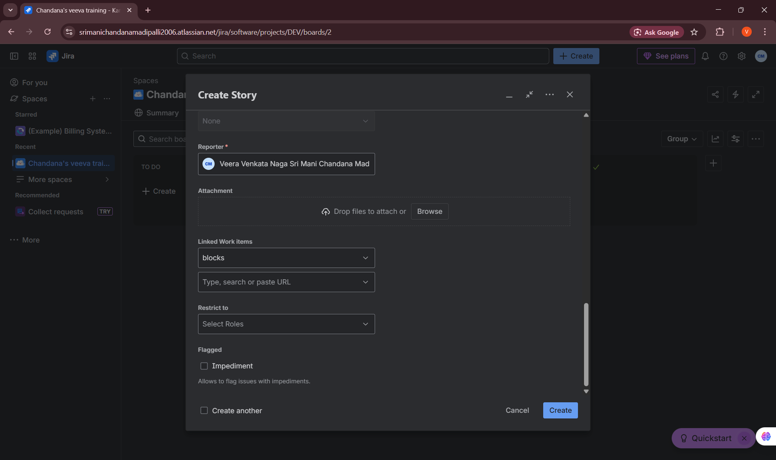

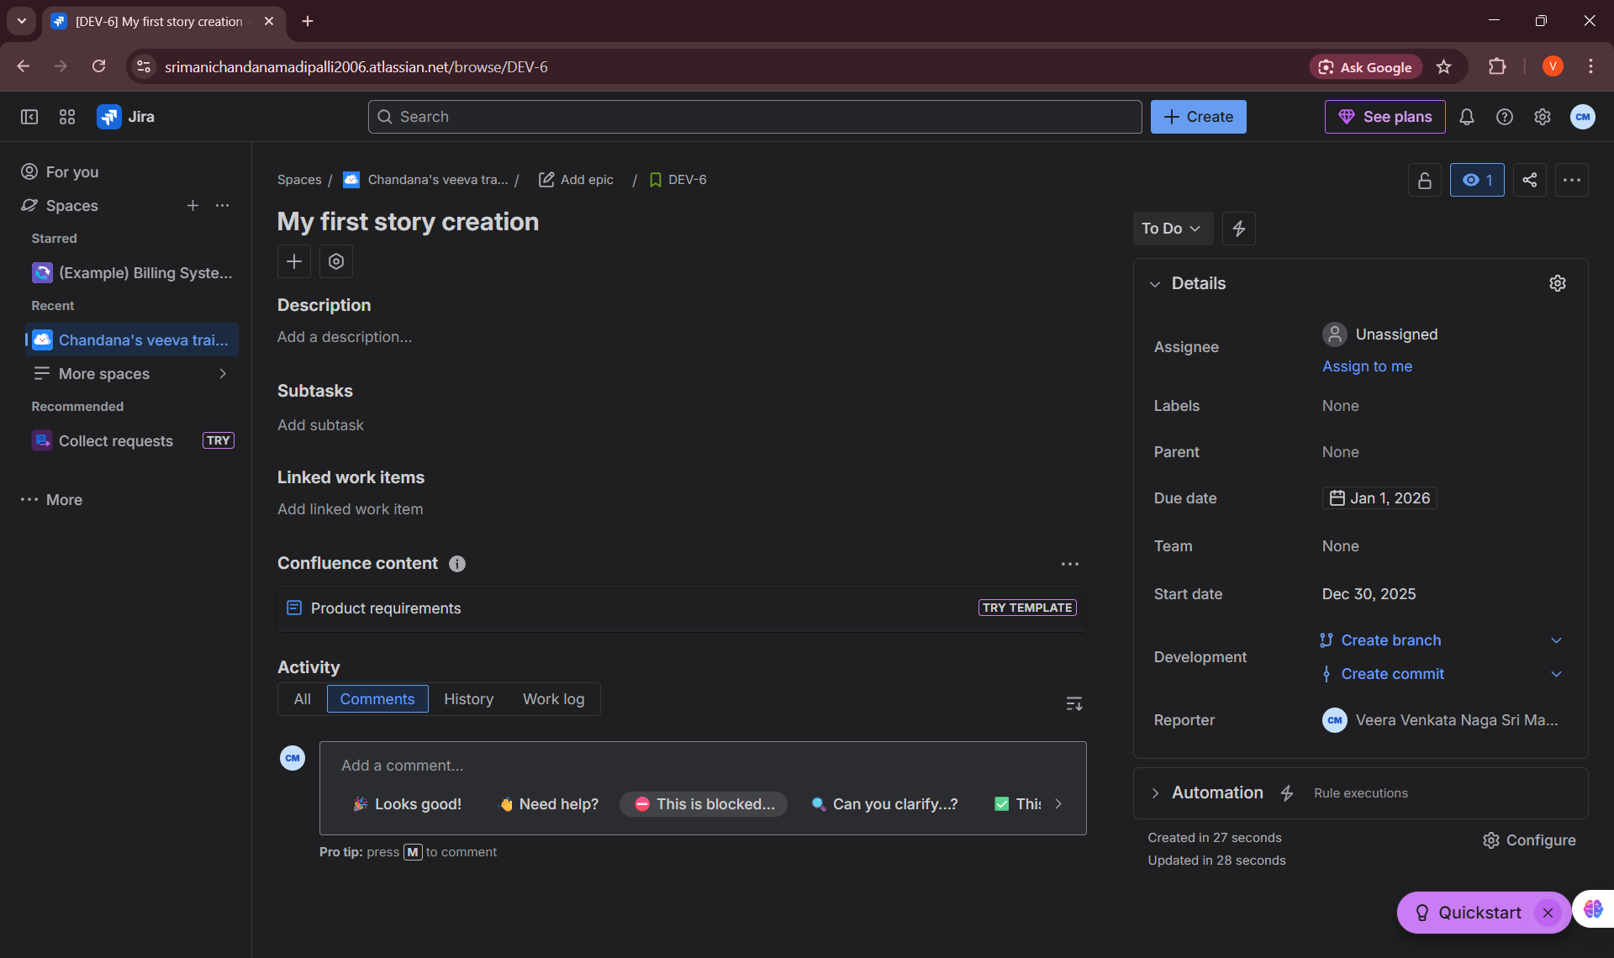

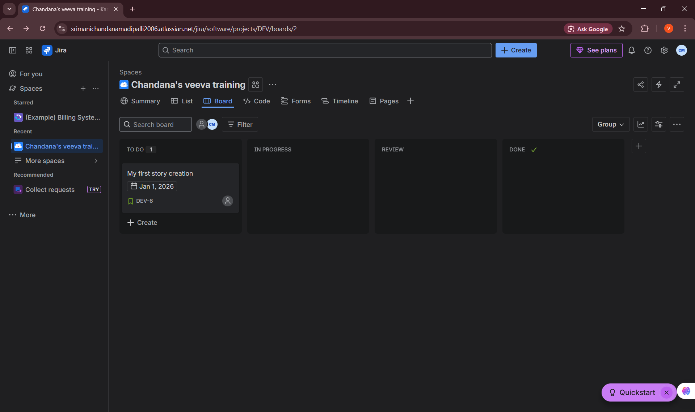
4. Task
Definition:
• A Task is a unit of work that needs to be completed but does not necessarily deliver direct user-facing functionality.
Learning Details:
• Tasks are used for technical, documentation, configuration, or maintenance work
• Tasks can exist independently or be linked to stories or epics
• Tasks support the completion of larger features
My practice:
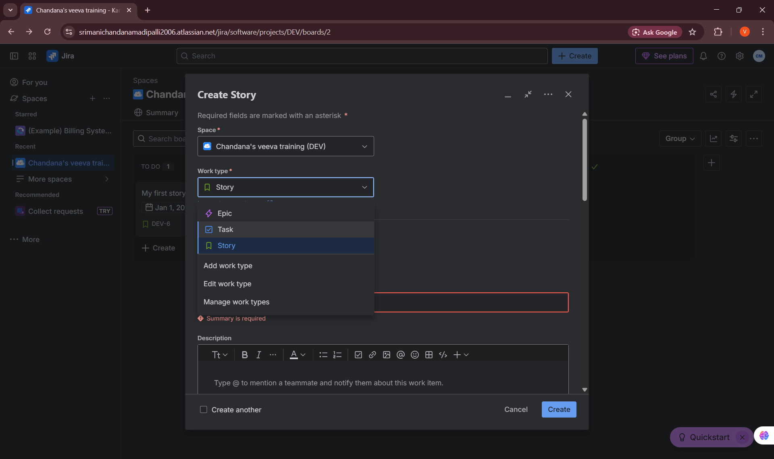

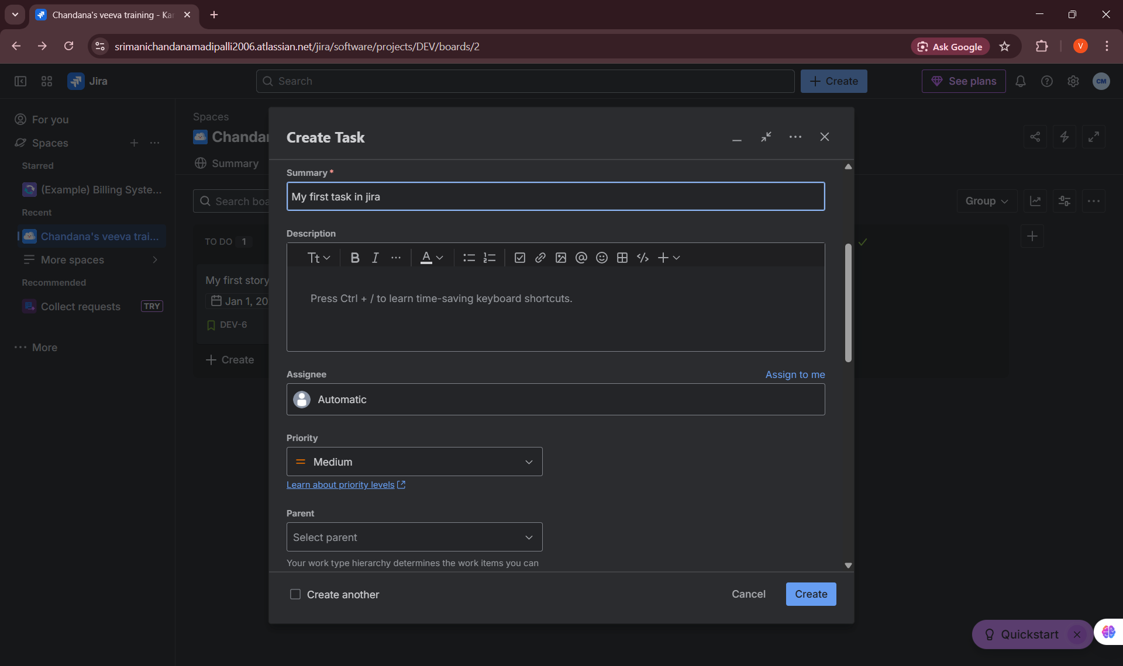

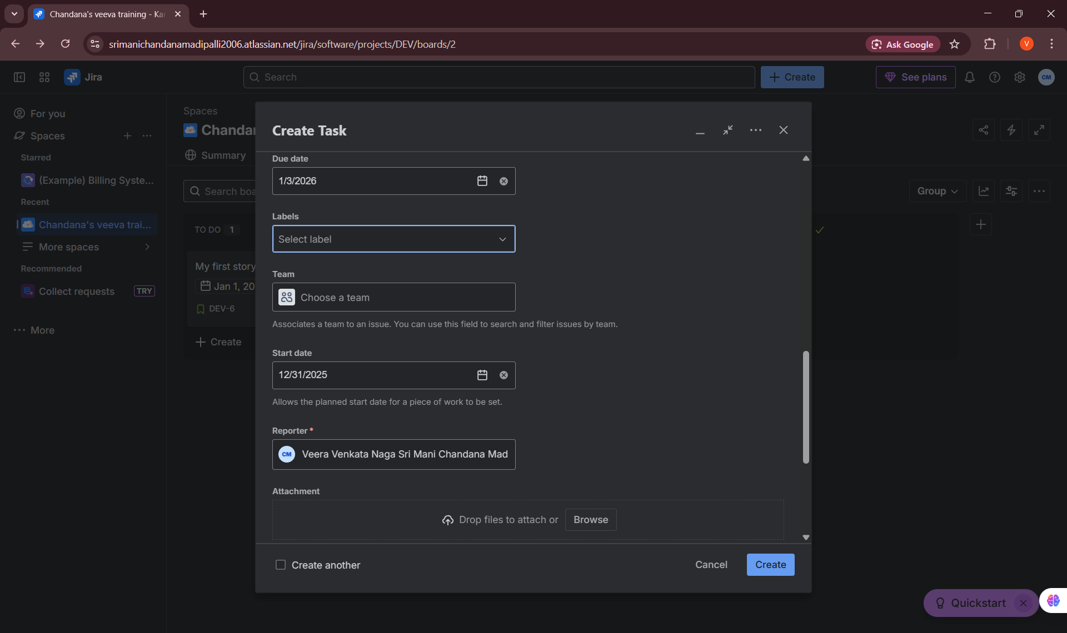

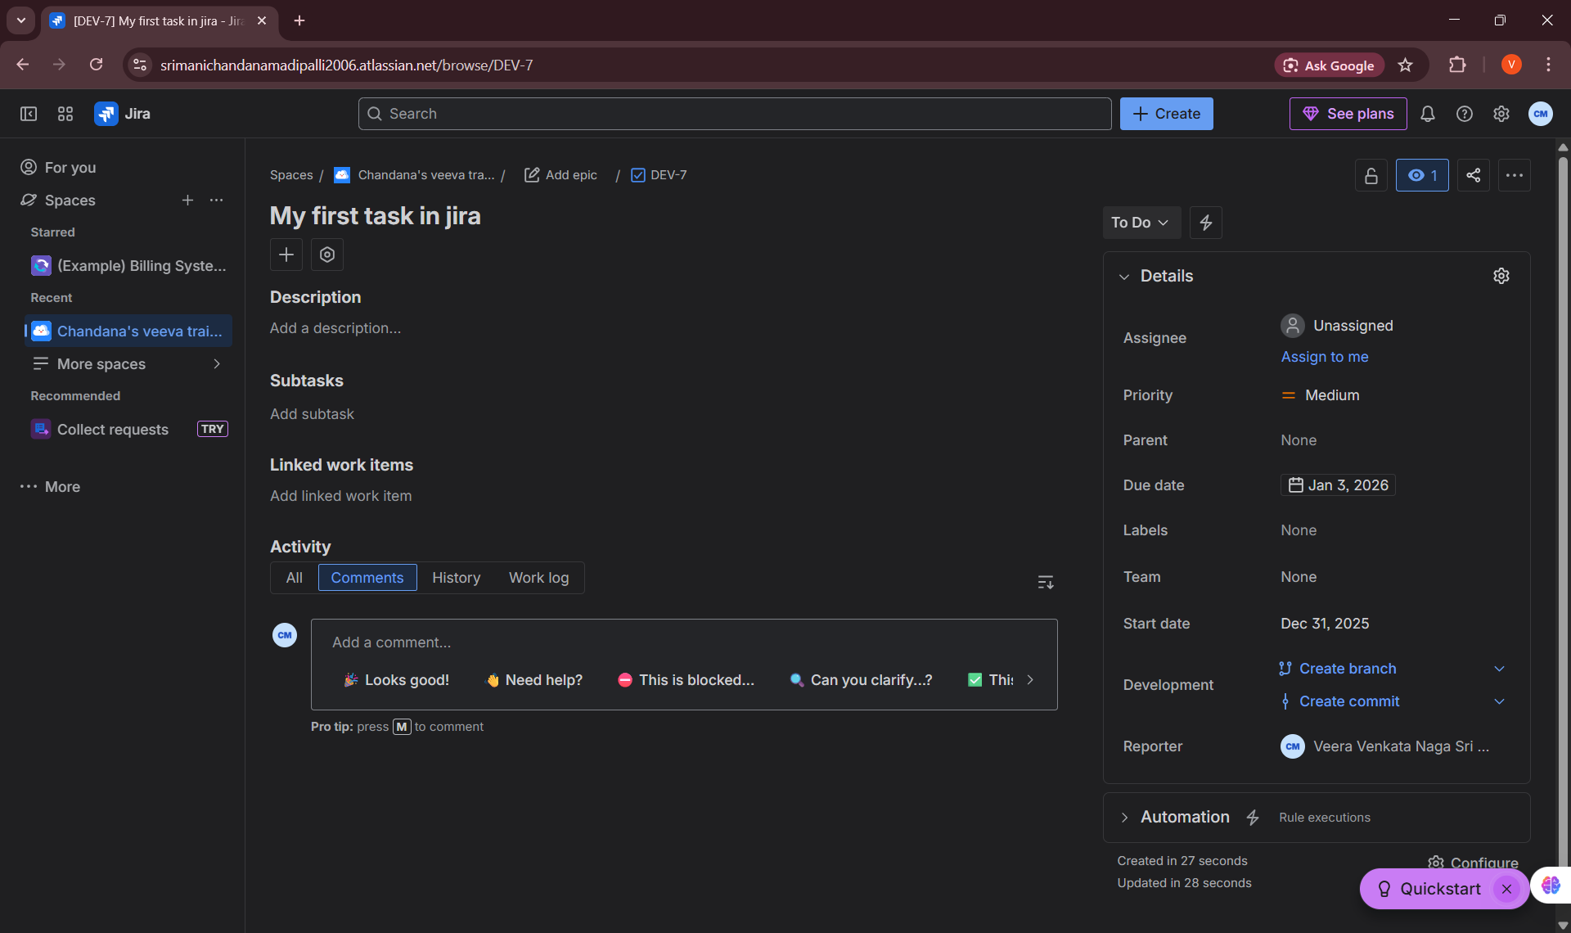

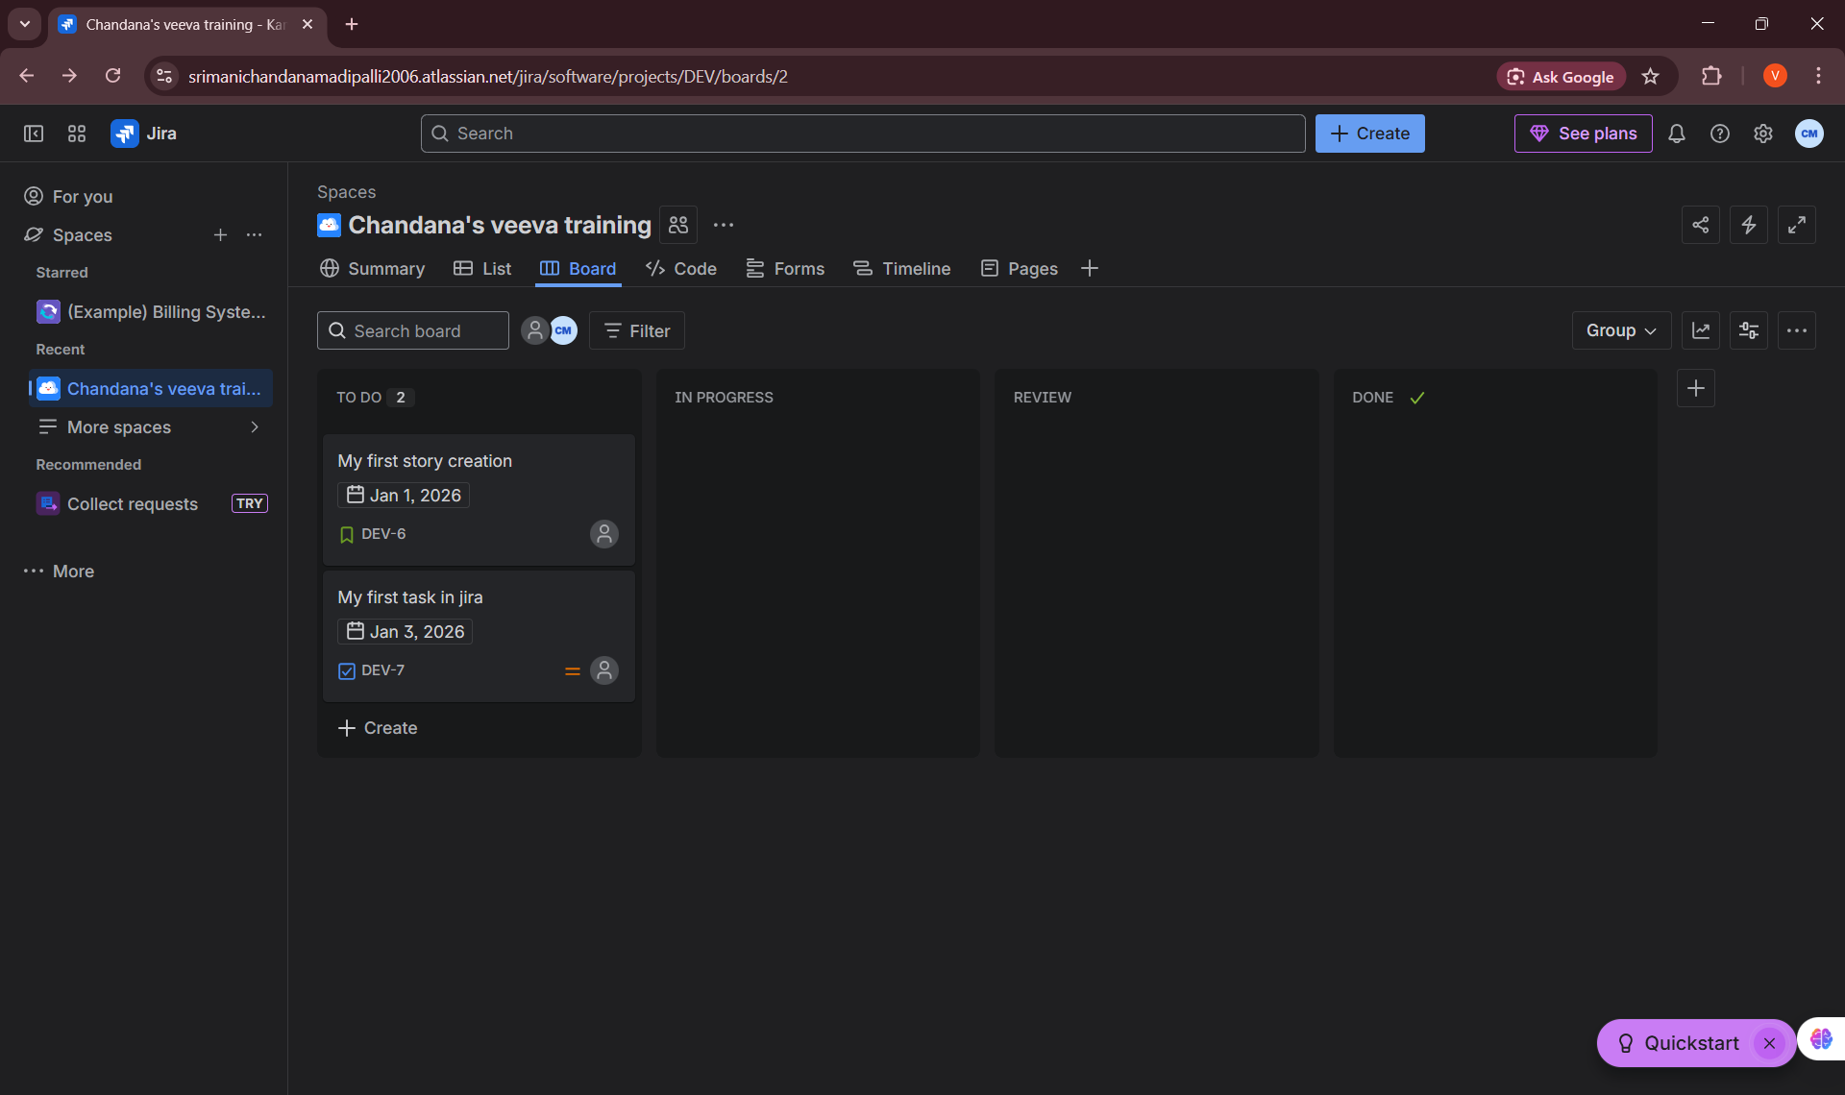
5. Bug
Definition:
• A Bug is a defect, error, or unexpected behavior in the application that causes it to function incorrectly or differently than expected.
Learning Details:
• Bugs are identified during testing or production usage
• Bugs are prioritized based on severity and business impact
• Bug tracking helps maintain software quality and stability
My practice:
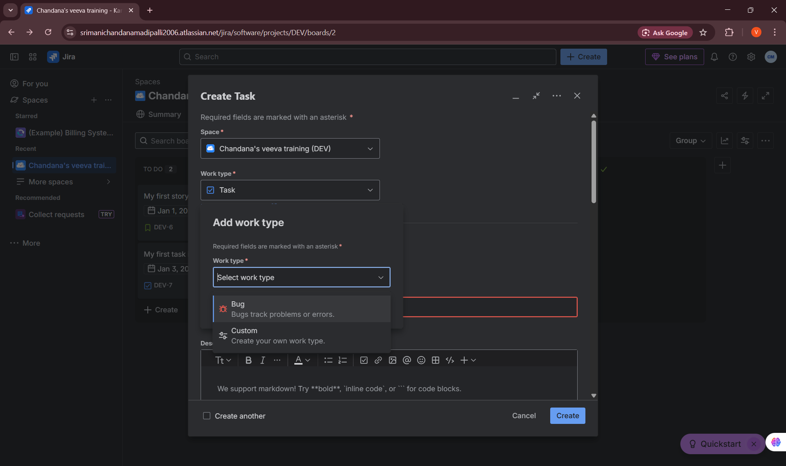

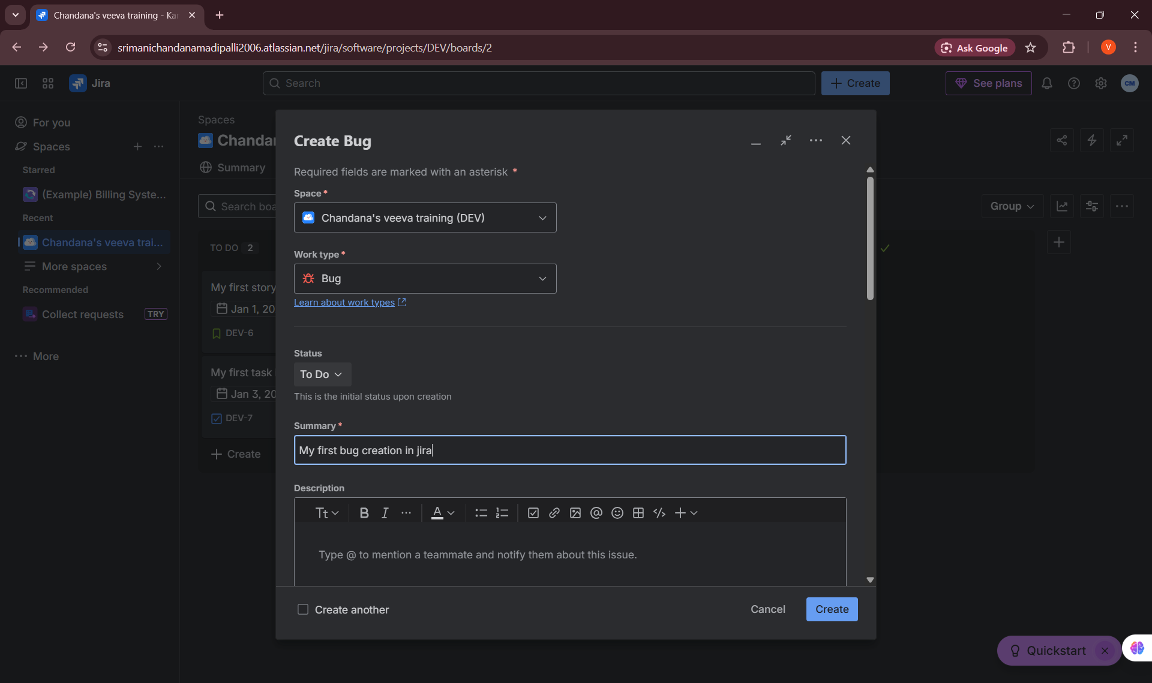

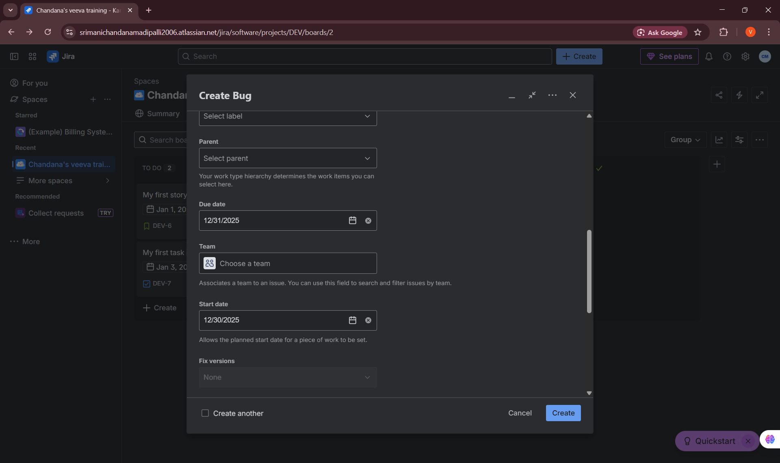

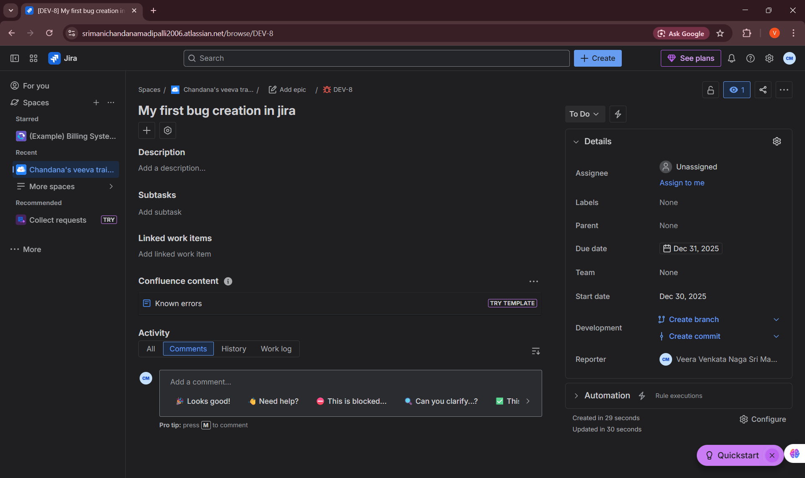

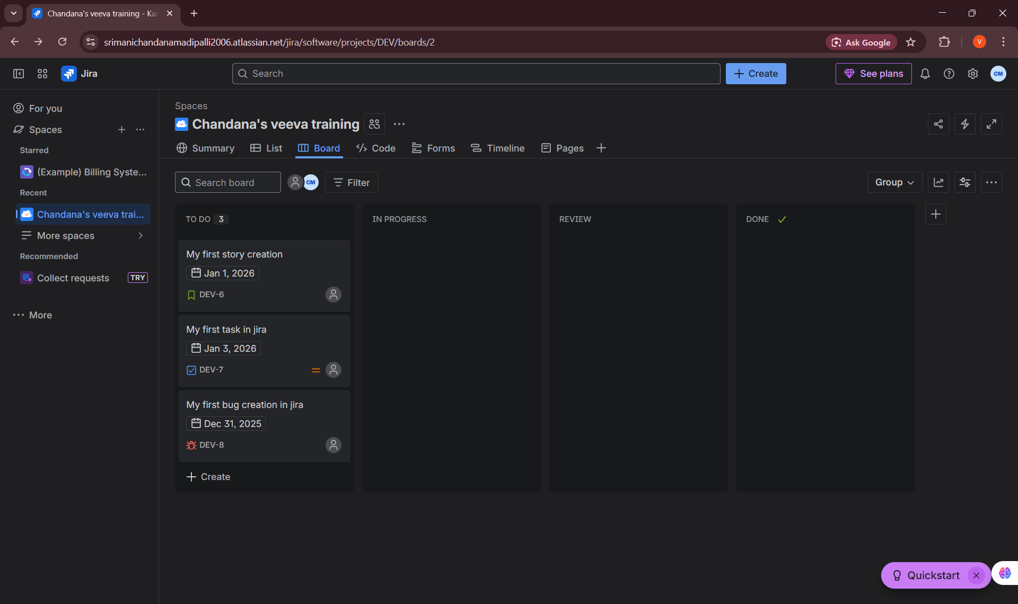
6. Creating Issues of Each Type
• Created sample Epic, Story, Task, and Bug issues in JIRA
• Entered issue details such as summary, description, priority, assignee, and labels
• Linked stories, tasks, and bugs to an epic to understand issue hierarchy
• This hands-on practice improved confidence in issue creation and lifecycle management
Key Learnings & Outcomes
• Gained a clear understanding of the meaning and purpose of each JIRA issue type
• Learned how to break down work effectively using Epics, Stories, Tasks, and Bugs
• Developed hands-on experience in creating and linking issues
• Improved ability to track development work and defects
• Built a strong foundation for sprint planning and Agile execution in JIRA

